|  |  |  |  |  |  |
| --- | --- | --- | --- | --- | --- |
| **NO** | **COMPONENTS** | **QUANTITY**  **(PCS)** | **ESTIMATED PRICE** | **REAL PRICE** | **INQUIRY** |
| 1 | Resistor 100 ohm | 01 | 4 birr |  |  |
| 2 | SPST with Red Light Indicator On OFF Boat Rocker Switch | 01 | 15 birr |  |  |
| 3 | Battery 9V | 01 | 75 birr |  |  |
| 4 | Battery Plug | 01 | 50 birr |  |  |
| ***Estimated Total*** | | | ***144 birr*** |  |  |

**AUTOMATED PARKING GARAGE SYSTEM USING IR SENSOR**

**Required Modules, Parts and Components**

1. Resistor 100ohm

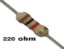

1. SPST Switch

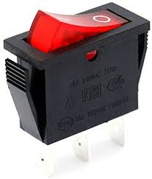

1. 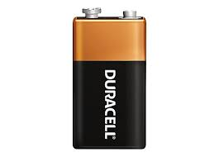Battery 9V
2. Battery plug

